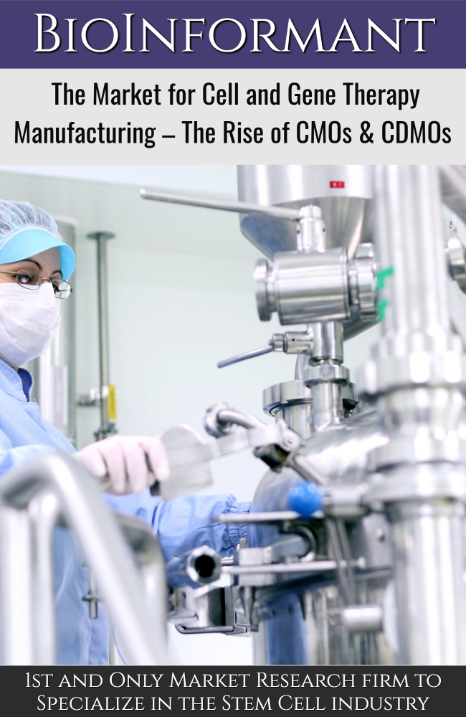
TABLE OF CONTENTS
1. Funding the Cell and Gene Therapy Boom 7

1.1 Recent CMO/CDMO Expansions in Cell and Gene Therapy Sector 9
1.1.1 Expected Capacity Crunch 9
1.1.2 Investments for CGT Capacity Expansion 10
1.1.3 Other CGT Manufacturing Investments 11
1.1.4 Events Driving Expansion for CGT Facilities and Infrastructure 11
1.1.4.1 Lyell Immunopharma 13
1.1.4.2 ElevateBio 13
1.1.4.3 Thermo Fisher Scientific 13
1.1.4.4 Biogen 14
1.1.4.5 Rentschler Biopharma 14
1.1.4.6 FUJIFILM Corporation 14
1.1.4.7 Thermo Fisher Scientific, Inc. and Henogen S.A. 15
1.1.4.8 Genezen Laboratories 15
1.1.4.9 Thermo Fisher Scientific – Global Expansion Across 3 Sites 15
1.1.4.10 Minaris Regenerative Medicine 16
1.1.4.11 AGC Biologics 16
1.1.4.12 Lonza 17
1.1.4.13 Samsung Biologics 17
1.1.4.14 Forge Biologics 17
1.1.4.15 Polpharma Biologics 18
1.1.4.16 Sekisui Diagnostics 18
1.1.4.17 Bionova Scientific 18
1.1.4.18 WuXi Biologics 18
1.1.4.19 Fujifilm Diosynth Biotechnologies 19
1.1.4.20 Merck KGaA 19
1.1.4.21 Exothera 20
1.1.4.22 ChemPartner 20
1.1.4.23 Hitachi Chemical Advanced Therapeutics Solutions 20
1.1.4.24 Krystal Biotech 20
1.1.4.25 Center for Breakthrough Medicines 21
1.1.4.26 The Discovery Labs 21
1.1.4.27 Piramal Pharma Solutions 21
1.1.4.28 Catalent 22

2. Recent Merger and Acquisition (M&A) Deals within the Cell and Gene Therapy Sector 23
2.1 Charles River Laboratories International/Retrogenix 23
2.2 Charles River Laboratories International/Cognate BioServices 24
2.3 Beam Therapeutics/Guide Therapeutics 24
2.4 Thermo Fisher Scientific/Henogen 24
2.5 Eli Lilly/Prevail Therapeutics 24
2.6 Novartis/Vedere Bio 25
2.7 Bayer/Asklepios 25
2.8 AGC Biologics/MolMed 25
2.9 Sorrento Therapeutics/SmartPharm 25
2.10 Catalent/MaSTherCell 26
2.11 ElevateBio 26
2.12 Ixaka 26

3. Financing Rounds 27
3.1 Major Private Placements 28
3.1.1 Orchard Therapeutics 29
3.1.2 Amryt 29
3.1.3 BioNTech 30
3.1.4 Kiadis Pharma 30
3.2 Major Venture Capital Financings 31
3.2.1 ElevateBio 31
3.2.2 Century Therapeutics 32
3.2.3 Artiva Biotherapeutics, Inc. 32
3.2.4 Vineti, Inc. 32
3.2.5 Ori Biotech Ltd. 33
3.2.6 Neogene Therapeutics 33
3.2.7 Forge Biologics 33
3.2.8 Sana Biotechnology 33
3.2.9 Orca Bio 34
3.2.10 Freeline Therapeutics 34
3.2.11 Poseida Therapeutics 34
3.2.12 Kriya Therapeutics 34
3.2.13 Legend Biotech Corporation 35
3.2.14 Lyell Immunopharma 35
3.2.15 Mammoth Biosciences 35
3.2.16 Kyverna Therapeutics 35
3.3 Major Corporate Partnerships within the CGT Market 36
3.3.1 Bayer/Atara Biotherapeutics 36
3.3.2 Novartis/Mesoblast 37
3.3.3 Novartis/Sangamo 37
3.3.4 Janssen Biotech/Fate Therapeutics 37
3.3.5 Biogen/Sangamo 38
3.4 Follow-on Public Offerings by CGT Companies 38
3.4.1 Rocket Pharmaceuticals 39
3.4.2 Adaptimmune Therapeutics 39
3.4.3 Allogene Therapeutics 39
3.4.4 Iovance Biotherapeutics, Inc. 39
3.4.5 Bluebird bio 40
3.5 Initial Public Offerings (IPO) 40
3.5.1 Legend Biotech 41
3.5.2 Decibel Therapeutics 41
3.5.3 Sana Biotechnology 41
3.5.4 Rocket Pharmaceuticals 41
3.5.5 JW Therapeutics 42
3.5.6 AlloVir 42
3.5.7 Akouos 42
3.5.8 Generation Bio 42
3.5.9 Passage Bio 43
3.5.10 Beam Therapeutics 43

4. Market Size for Cell and Gene Therapy CMO/CDMOs 44

5. Profiles of Cell and Gene Therapy CMOs and CDMOs 47
5.1 3P Biopharmaceuticals 47
5.1.1 Services 47
5.2 ABL, Inc. 48
5.2.1 Biomanufacturing Services 48
5.3 AGC Biologics 49
5.4 Advent BioServices Ltd. 49
5.5 Akron Biotech 50
5.6 Aldevron 51
5.6.1 Platforms 51
5.6.2 Services 51
5.7 Anemocyte S.r.l 52
5.8 Applied Viromics 53
5.8.1 AAV Vectors 53
5.8.2 Adenovirus 53
5.9 ATVIO Biotech, Ltd./Orgenesis Biotech Israel, Ltd. 54
5.9.1 Services 54
5.10 Austrianova 55
5.10.1 Services 55
5.11 Avid Bioservices, Inc. 56
5.11.1 Services 56
5.12 Batavia Biosciences B.V. 57
5.13 Bio Elpida 58
5.13.1 Services 58
5.14 BioCentriq 59
5.14.1 Clinical Manufacturing Services 59
5.14.2 Process Development Services 60
5.15 BioNTech IMFS GmbH 61
5.16 BioReliance Corporation/Merck Millipore 62
5.16.1 Services 62
5.17 Bio-Techne 63
5.17.1 Bioprocessing Services 63
5.17.2 Cell and Gene Therapy Services 63
5.18 Biovian Oy 64
5.18.1 Services 64
5.19 Boehringer Ingelheim BioXcellence 65
5.19.1 Services 65
5.20 Brammer Bio/Thermo Fisher Scientific 66
5.21 C3i 66
5.21.1 Biomarker and Diagnostic Unit 67
5.21.2 GMP Manufacturing Unit 67
5.22 Catalent Biologics 68
5.22.1 Services 68
5.23 CATAPULT 69
5.23.1 Facility at London 69
5.23.2 Facility at Stevenage 70
5.23.3 Facility at Braintree 70
5.23.4 Catapult’s Capabilities 70
5.24 CCRM 71
5.24.1 CDMO Services 71
5.24.2 Process Development Lab 72
5.25 Cell Therapies Pty Ltd. 73
5.25.1 Services 73
5.26 CELLforCURE (Novartis) 74
5.27 Celonic AG 75
5.27.1 Capabilities 75
5.28 Cellular Therapeutics Ltd. 76
5.29 Center for Breakthrough Medicines 77
5.29.1 Process Development 77
5.29.2 Analytical Method Development and Testing 77
5.29.3 Plasmid DNA 77
5.29.4 Adeno-Associated Virus 78
5.29.5 Lentivirus 78
5.29.6 Adenovirus 78
5.29.7 Cell Banking 78
5.29.8 Cell Processing 79
5.30 Charles River Laboratories International, Inc. 79
5.30.1 Cell Therapy Services 79
5.30.2 Gene Therapy Services 79
5.31 Cobra Biologics 80
5.31.1 Viral Vector Platform Process Development & Scale up 80
5.31.2 GMP Cell Banking & Viral Seed Stocks 80
5.31.3 GMP Manufacture 80
5.31.4 Viral Vector Analytical Development & Qualification 81
5.32 Cognate BioServices 81
5.33 Delphi Genetics S.A. 82
5.33.1 Services 82
5.34 ElevateBio 83
5.35 Emergent BioSolutions 83
5.35.1 Contract Development 83
5.36 Eurogentec 84
5.36.1 Services 84
5.37 Exothera 85
5.37.1 Services 85
5.38 FinVector 86
5.38.1 Services 86
5.39 Flash Therapeutics 87
5.39.1 Partnered Clinical Programs 87
5.40 Fraunhofer Institute for Cell Therapy and Immunology 88
5.40.1 Services 88
5.41 FUJIFILM Cellular Dynamics, Inc. 89
5.41.1 Products 89
5.41.2 The Innovation Facility for Advanced Cell Therapy (iFACT) 90
5.41.3 CDMO Services 91
5.41.3.1 iPSC Technical Expertise 91
5.41.3.2 Advanced Cell Technology and Manufacturing Expertise 91
5.41.3.3 iPSC-derived Cardiomyocytes 92
5.41.3.4 iPSC-derived Neural Cells 92
5.41.3.5 iPSC-derived Immune Cells 92
5.42 FUJIFILM Diosynth Biotechnologies 93
5.42.1 Services 93
5.43 GenScript Biotech Corporation 94
5.43.1 Services 94
5.44 KBI Biopharma 95
5.44.1 Capabilities & Services 95
5.45 Lonza Group Ltd. 96
5.45.1 Capabilities & Expertise 96
5.45.2 Services 96
5.46 MaSTherCell 97
5.46.1 Services 97
5.47 Matica Biotechnology, Inc. 98
5.47.1 Services 98
5.48 Medinet Co., Ltd. 99
5.48.1 Services 99
5.49 Minaris Regenerative Medicine, LLC 100
5.49.1 Cell Therapy Expertise 100
5.50 MolMed S.p.A 102
5.50.1 Capabilities 102
5.51 NECSTGEN 103
5.51.1 Services 103
5.52 NEOBIOSIS, LLC 104
5.53 NIKON CeLL Innovation Co., Ltd. 104
5.53.1 Services 104
5.54 Ology Bioservices, Inc. 105
5.54.1 CDMO Services 105
5.55 OrganaBio 106
5.55.1 Services 106
5.56 Orgenesis 107
5.56.1 POCare Therapies 107
5.57 OxfordBiomedica plc 107
5.57.1 Bioprocessing Capability 108
5.58 Patheon/Thermo Fisher Scientific 108
5.58.1 Viral Vector Services 108
5.59 Performance Cell Manufacturing 109
5.59.1 Services 109
5.60 Q-Gen Cell Therapeutics 110
5.60.1 Services 110
5.61 RoslinCT 111
5.61.1 Services 111
5.62 Samsung Biologics 112
5.62.1 Services 112
5.63 SK biotek 113
5.63.1 Services 113
5.64 Stanford Laboratory for Cell and Gene Medicine 114
5.64.1 Current Projects 114
5.64.2 Services 114
5.65 Stemmatters, Biotechnologia e Medicina Regenerativa S.A. 115
5.65.1 Capabilities & Facilities 115
5.66 Takara Bio Europe SAS 116
5.66.1 Services 116
5.67 TUM Cells 117
5.68 Interdisciplinary Stem Cell Institute/Miami University 117
5.69 Upstate Stem Cell cGMP Facility 118
5.69.1 Capabilities 118
5.70 VGXI, Inc. 119
5.70.1 Services 119
5.71 Vigene Biosciences, Inc. 120
5.71.1 Services 120
5.72 Waisman Biomanufacturing 121
5.72.1 Services 121
5.73 Yposkesi 122
5.73.1 Services 122

INDEX OF FIGURES

FIGURE 1.1: Survey Respondent’s Plans for In-House Capacity Expansion 10
FIGURE 3.1: Gene Therapy Financings, 2016-2020 28
FIGURE 4.1: Global Market for CGT Manufacturing by CMO/CDMOs, 2020-2027 46

INDEX OF TABLES

TABLE 1.1: Recent CMO/CDMO Expansions in Cell and Gene Therapy Sector 12
TABLE 2.1: Recent Merger and Acquisition (M&A) Deals in Cell and Gene Therapy Sector 23
TABLE 3.1: Cell and Gene Therapy Financings, 2016-2020 27
TABLE 3.2: Major Private Placement Offerings with the CGT Market 29
TABLE 3.3: Major Venture Capital Financings 31
TABLE 3.4: Major Corporate Partnerships 36
TABLE 3.5: Follow-on Offerings by CGT Companies 38
TABLE 3.6: Major CGT Company Initial Public Offerings (IPOs) in 2020 and 2021 40
TABLE 4.1: Global Market for CGT Manufacturing by CMO/CDMOs, 2020-2027 45

About BioInformant

As the first and only market research firm to specialize in the stem cell industry, BioInformant research is cited by the Wall Street Journal, Nature Biotechnology, Xconomy, and Vogue Magazine.

Serving market leaders that include Pfizer, Goldman Sachs, Beckton Dickinson, and GE, BioInformant is your global leader in stem cell industry data.

Learn more at www.BioInformant.com.

BioInformant Worldwide, LLC
www.BioInformant.com

